Feedback for v1.189

Overall
- Input text colour should all be black across all pages
- Headings can remain grey
- I can’t see where the tax rates are being applied – let’s add columns under Current Asset Allocation in Client details

Application Settings
- Changing text under Application Title is a bit clunky; backspace deletes one letter at a time

Capital Market Estimates
- Backspace doesn’t delete number
- Can’t enter more than one digit at a time – reverts to one decimal place
- Under Capital Markets Estimates, replace “Expected Return %” with “Expected Return (%)” and replace “Expected SD %” with “Expected SD (%)” and align with format such that (%) is on second row)
- Can we resize columns so that the % columns are equal width
- Replace “Add Custom Asset Class” with “Add Asset Class”
- Remove “Include” and add bin on right hand side to remove asset class
- Add “Add Asset Class” to the Correlation table so that new asset classes can be added
- Add bin to Correlation table to remove asset class
- Under Tax Rates, replace “Superannuation (Pensions Phase)” with “Superannuation (Pension Phase) – sorry! That was my mistake originally

Client details
- Add columns per entity “Expected Return” and “Expected Risk” – the data for these should automatically populate based on the formula I provided in the spreadsheet. This should then be used for the optimisation
- Add a “Total” row under each entity asset allocation; if Total doesn’t add up to 100%, show in red
- Can we have a default of 100% allocation to cash?

Optimisation
- Please make this the second tab
- The output doesn’t look quite right. If I run 1 simulation, I expect to see 1 dotted curve plus the portfolios but I see about 7. Is the methodology to run multiple scenarios per simulation? Strangely, the chart kept on refreshing after testing 500 simulations…
- Why does the Pre-tax chart not show any simulations? I would expect to see the same as for post-tax, with the curve being a bit higher
- The chart is still resizing rather than remaining static with 0% starting point on both axes.
- Remove pop up text box under “Simulations”
- Do you have metrics for “Forecast Confidence”? ie what does “High (Precise)” actually mean? Is this 9/10 confidence? How is it calculated? When would I not use “High (Precise)”?
- Remove “View Returns”
- Replace “Pre-Tax” with “Before Tax” and “After-Tax” with “After Tax”
- Please remove the descriptive labels for portfolios – they should only have a number
- Remove “Portfolio Composition Map (Michaud)” – this is nice, but when I’ve used it with clients in the past they get confused!

Projections Input
- Can we incorporate this page into the Projections Output page at the top and just rename that tab “Projections”?
- Remove colours of “Inflow” and “Outflows”

Output
- Please make this the third tab
- Remove text description of portfolios – should be numbers only
- Replace colours for “Return” and “Risk” with black
- Can the pie chart colour scheme be a bit more muted / pastel
- The output is not correct – the same allocation is applied across all entities
- In some instances, cash is showing as negative allocation
- Can we try to employ a rule where asset classes with more than 50% proportion of return is income, the preference is in order:
  - Superannuation (pension phase)
  - Superannuation (accumulation phase)
  - Family Trust
  - Company
  - Personal name
- Can we show asset classes with 0% allocation as “0.0% in the table rather than omitting them (but there should always be an allocation to each asset class for portfolios 2- 9)
- Replace “$$” with “Amount ($)”
- Remove “ASSET” under “Asset Allocation” and “Asset Allocation by Entity”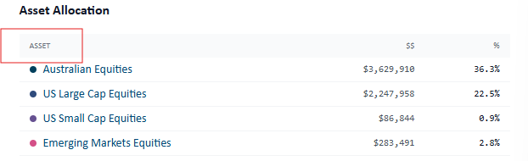

Projections Output
- Please change the default Wealth Projection chart colour to blue
- Change font colour in pop up box to black
- When toggling from Before to After Tax, can we keep the Wealth Projection chart parameters the same so it doesn’t resize – easier to compare
- Nominal and real button not linked to inflation data box for wealth projection?
- Under Estimating Outcomes, I expect the median (and therefore up and downsides) to increase over time – please check your calculations here as in some scenarios it increased then decreased over time
- Please change the default Estimating Outcomes chart colour to blue as the main colour
- When toggling from Real to Nominal, can we keep the Estimating Outcomes chart parameters the same so it doesn’t resize
- Remove “Year” after the year
- Change format from all caps to regular
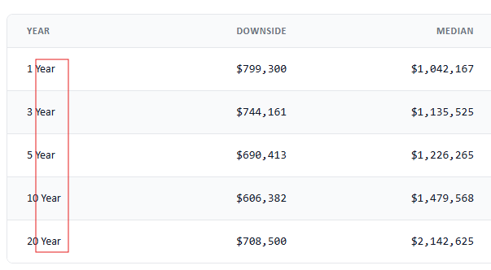
- Change format from all caps to regular

